1.Determine value of K using MATLAB

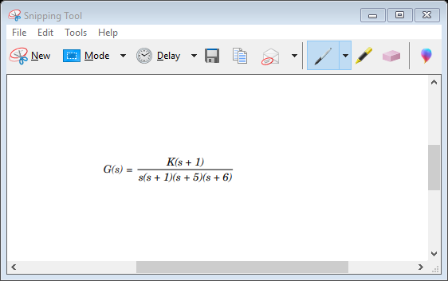

>> %MATLAB Program

>> K = [0:0.2:200];

>> for i = 1: length (K);

>> deng = poly ([0 –1 – 5 – 6]);

>> dent = deng + [0 0 0 K (i) K (i)];

>> R = roots (dent);

>> A = real(R);

>> B = max (A);

>> if B > 0

>> R

>> K = K (i)

>> break

>> end

>> end Computer response: R = – 10.0000 – 0.5000 + 4.4441i – 0.5000 – 4.4441i – 1.0000

A = – 10.0000 – 0.5000 – 0.5000 – 1.0000

B = – 0.5000

Q.2 Obtain Nyquist plot

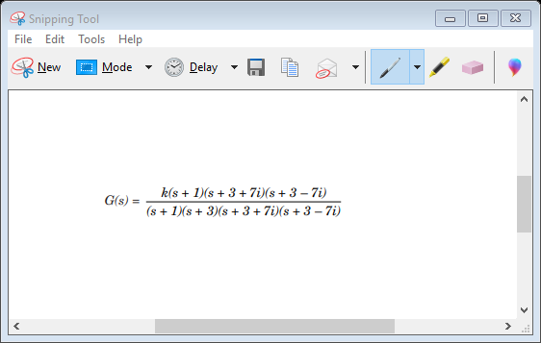

>> %MATLAB Program

>> %Simple Nyquist plots

>> clf >> z = [– 1 – 3 + 7\*i – 3 – 7\*i];

>> p = [– 1 – 3 – 5 – 3 + 7\*i – 3 – 7\*i];

>> k = 30;

>> [num, den] = zp2tf (z’, p’, k);

>> subplot (211), nyquist (num, den)

>> ngrid

>> axis ([50 360 – 40 30])

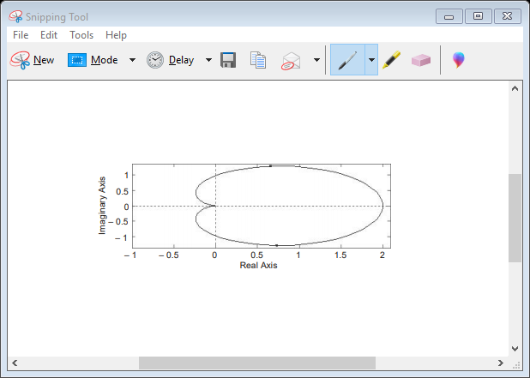

Q.3 Draw Bode Plot

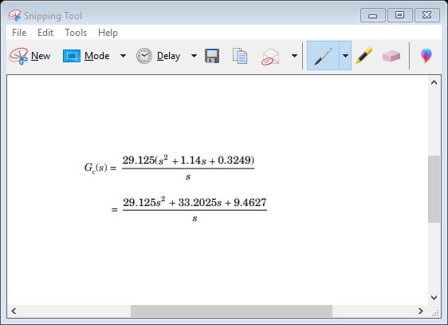

>> %MATLAB Program

>> %Bode diagram

>> num= [29.125 33.2025 9.4627];

>> den= [0 1 0];

>> bode (num, den)

>> title (‘Bode diagram of G(s)’)

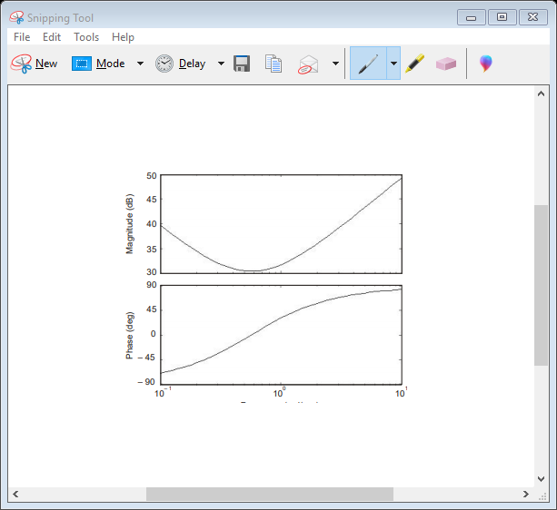

Q4. (a) plot the Nyquist diagram

(b) Display the real-axis crossing value and frequency

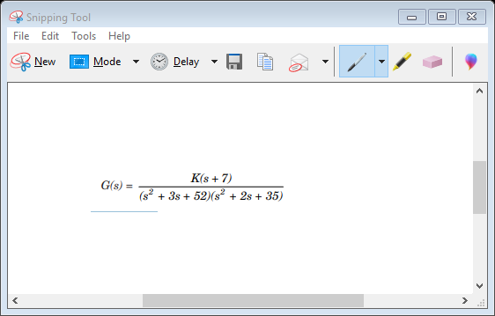

>> %MATLAB Program

>> numg = [1 7]

>> deng = conv ([1 3 52], [1 2 35]);

>> G = tf (numg, deng)

>> ‘G(s)’ >> Gap = zpk (G)

>> inquest (G)

>> axis ([– 3e – 3, 4e – 3, – 5e – 3, 5e – 3])

>> w = 0:0.1:100;

>> [re, im] = nyquis t (G, w);

>> for i =1:1: length (w)

>> M(i) = abs (re (i) + j\*im (i));

>> A (i) = atan2 (im (i), re (i))\*(180/pi);

>> if 180 – abs (A (i)) <= 1;

>> re (i);

>> im (i);

>> K = 1/abs (re (i));

>> fprintf (‘\nw = %g’, w(i))

>> fprintf (‘, Re = %g’, re (i))

>> fprintf (‘, Im = %g’, im (i))

>> fprintf (‘, M = %g’, M (i))

>> fprintf (‘, K = %g’, K)

>> Gm = 20\*log10 (1/M (i));

>> fprintf (‘, Gm = &G’, Gm)

>> break

>> end

>> end

Computer response: numg = 1 7

ans = G(s)

Zero/pole/gain:

(s + 7)

-------------------------------

(s^2 + 2s + 35) (s^2 + 3s + 52)

